FILM TARIFFS (0:29 - 4:14)

The US president Donald Trump recently announced plans to impose a 100% tariff on films made outside of the US.

mega celebrity epic stunts opt to make films down under decimate an industry fantastic realms Hollywood's golden age visual effects
film infrastructure profound effect divert funds robust industry

- What is a tariff?
- Why does US president Donald Trump want to introduce a 100% tariff on films made outside of the US?
- Why are some Hollywood films made in Australia? How would the tariff impact on the Australian film industry? Why might the tariff be bad for US film makers?


- How do many countries, including Australia, try to attract overseas film and TV show productions to their shores? By offering …
- What does Trump say he will do before making any decisions?

WOMEN IN PARLIAMENT (6:15 - 10:22)

In this report, BTN looks at the place women have in the history of Australia’s parliaments.
- For a long time, no woman in the world had the right to vote. Why?

- How many women will have seats in Australia’s 150 seat House of Representatives?
- How many of the 76 Senate seats will be held by women?
- Which Australian government became only the second in the world to give women the right to vote in 1894?
- The new Australian federation passed similar laws but some states didn’t give the same rights to which group of people?
- In which year were the first women elected to federal Parliament?
- At the time, Parliament House didn’t even have _________________________
- In 2010, Australia got its first _________________________
- And in 2013, Nova Peris became the first _________________________ to sit in Parliament.

VE DAY ANNIVERSARY (10:22 - 15:50)

Last week the world commemorated the 80th anniversary of VE Day.

years of conflict suffering and sacrifice rise to power took advantage of military power restore to its former greatness Aryan strong allies wage war carry out a mass killing ethnic minorities air and sea mission honour the people

- What is VE Day? On which date is it commemorated? Why is it important to commemorate it?
- How did World War II begin? Which countries were involved? Why was Australia fighting in the conflict?
- What prompted the US to get involved?
- Which battle was the turning point in Germany’s war on the eastern front?
- What was the Holocaust?

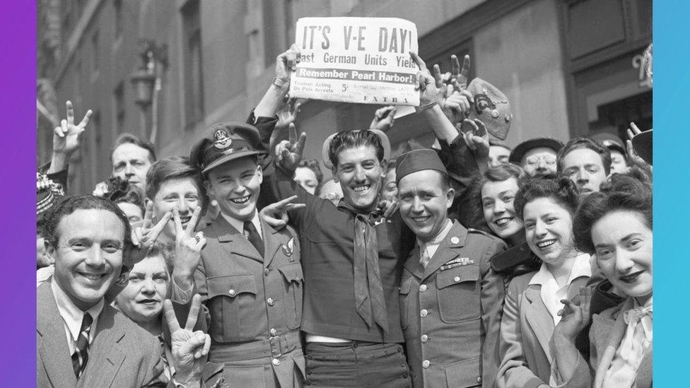

- Adolf Hitler rose to power in Germany the early ________________.
- In 1938, the Nazis took over which country?
- Then in 1939, Germany invaded ________________.
- The invasion then resulted in which 2 countries declaring war on Germany?
- Which country fought alongside Germany?
- How many people died in battles between Germany and the USSR?
- How many people died during the Holocaust?
- Which country’s troops were the first to arrive in Berlin?

WALK SAFELY TO SCHOOL DAY (16:15 - 19:54)

Australia children are being encouraged to walk safely to school.

- Did you normally walk to your school?
- Why are fewer children walking to school these days?
- What are the benefits for children who walk to school? How can this be done safely? Make notes below and discuss your ideas:
WALKING TO SCHOOL
Benefits

How to do it safely
- Tip 1: Avoid distractions
- Tip 2: Stop and check
- Tip 3: Know your route
- Tip 4: Join forces

- Statistics show that 40 years ago, around __________ of children got to school by walking or riding their bike. Now, only about one in __________ children do so.

SCHOOL SUPPORT DOG (21:12 - 24:10)

In this report we meet Iris, a school support dog.

- Do you like dogs?
- What does a support dog do? How can a dog help support students?
- What kind of temperament does a support dog need to have?

- How old is Iris?
- Iris was initially a ___________________ puppy.
- What are some rules?
  - If Iris has her bandana on, you can _________________
  - If she has her jacket on with no bandana, she's _________________
  - If she has no bandana and no jacket on, that means you can still _________________
- How long has Iris been at Wirreanda Secondary School?

Answers

FILM TARIFFS

- tax breaks (and other deals)
- meet with film industry officials

WOMEN IN PARLIAMENT

- at least 65
- 41
- South Australian government
- Indigenous people
- 1943
- women’s toilets
- female Prime Minister
- Indigenous woman

VE DAY ANNIVERSARY

- 1930s
- Austria
- Poland
- France and Britain
- Italy
- around 8 million
- 11 million
- the Soviet Army / the USSR

WALK SAFELY TO SCHOOL DAY

- 75%, five

SCHOOL SUPPORT DOG

- 6
- guide dog
- pat / pet her, working with someone, still pat / pet her
- 5 years

